Scottish Enterprise Biodiversity Duty Report 2014-2017

This report highlights the range of Scottish Enterprise actions taken during 2014 - 2017 to further the conservation of biodiversity. The report is a requirement of the Nature Conservation (Scotland) Act 2004 and follows an amendment to the Wildlife and Natural Environment (Scotland) Act 2011. The report is structured as follows:

- Introductory Information
- Mainstreaming
- Actions taken to improve biodiversity conservation
- Partnership working and Biodiversity Communications
- Biodiversity Highlights and Challenges
- Monitoring
Section 1: Introductory information
Scottish Enterprise is Scotland's national economic development agency and a non-departmental public body of the Scottish Government.
We work with partners in the public and private sectors to identify and exploit the best opportunities to deliver a significant, lasting effect on the Scottish economy.
Scottish Enterprise’s role is to create sustainable economic growth, whilst recognising the need for a more cohesive and resilient economy that ensures opportunities for all. Our focus continues to be on the critical role of boosting Scotland’s international competitiveness to support long-term economic growth.
Scottish Enterprise’s approach to low carbon and the natural environment
Scottish Enterprise believes that tackling climate change, as a provider of services and as an employer, is critically important in a 21st century economy. In our work with businesses and sector bodies we use our influencing role to promote awareness and encourage actions which combat climate change.
Scottish Enterprise recognises low carbon as an important area of opportunity for driving greater innovation in Scotland. Scotland already has competitive advantages in low carbon technologies and important strategic assets including our academic excellence and our expertise in oil and gas which will form the basis for long-term growth by companies. Even with the current uncertain economic conditions, the market opportunities relating to low carbon are continuing to grow, providing a platform for innovation for Scottish companies and sectors in energy, resource efficiency and renewables.

In support of the Scottish Government’s Energy Strategy, we will continue to work with companies to address the significant opportunities in the low carbon economy, including supporting the Scottish Government led Low Carbon Infrastructure Transition Programme and will continue to encourage companies to think about their own resource efficiency.

As an employer, we remain focused on continuing to improve environmental management across our operational offices and the properties we manage. Our carbon management plan outlines our climate change strategy and governance arrangements and includes:
- Climate change sponsorship by a senior Scottish Enterprise leader
- The production of an annual climate change report
- An expanded role and remit for our climate change group which sets our policy and strategy in climate change including biodiversity
- Internal Audit review and verification of all of our carbon reporting
- Completion of a Low Carbon assessment as a mandatory part of the approval of all Scottish Enterprise projects including identification of wider environmental impacts arising as a result of project delivery
- Embedding environmental criteria in our procurement processes

To further support SE’s commitment to embedding climate change SE has:
- Developed an Environmental Management System
- Achieved ISO 14001:2015 Environmental Management certification in January 2017
- Achieved the gold award of the Resource Efficient Scotland Pledge

Section 2: Mainstreaming
Maximising the benefits of the low carbon economy is also a key focus for Scottish Enterprise through our work and support of circular economy approaches and specific sector developments such as Industrial Biotechnology. We also do this through the delivery of a range of sector projects which progress climate change including; The Low Carbon Infrastructure Transition Programme, the Low Carbon Heat Market Support Programme and the Hydro Nation Water Innovation Service.
Sustainability Specialists

Our team of sustainability specialists work with companies to identify, develop and deliver projects which lead to improved business efficiency.

The aim of our support is to:
- improve the efficiency of premises, products and processes - leading to reduced costs and improved environmental performance.
- ‘future proof’ business practices - including opportunities to address climate change adaptation.

The Scottish Enterprise Sustainability Specialists have a diagnostic tool which uses a question set covering 5 general areas of activity: Management Commitment; Resource Management; Compliance & Risk; Customers & Supply Chain; and Corporate Social Responsibility. The Corporate Social Responsibility section contains questions relating to biodiversity activities undertaken by the company being assessed.
Examples of biodiversity practices undertaken by companies supported, include:
- Consulting botanists when considering the establishment of a natural garden on site
- Promoting and supporting colleagues to grow vegetables on site.
- Considering biodiversity in plans for new builds, including how planting and landscaping on site will encourage biodiversity.
- In one case, the potential impact of a new build on the local seal population was part of the overall assessment and diligence undertaken.
- Tree planting on site and being sensitive to wildlife corridors.
- Consideration of bird nesting issues
- Establishing landscape management plans as part of integrated management systems.

Sustainable Procurement
The Scottish Enterprise Sustainable Procurement Strategy aims to ensure that sustainability is considered throughout the entire procurement life cycle, meeting our legal and financial obligations, following best practice and achieving economic, environmental and social benefits.
Environmental criteria are included in our requirements and our evaluation of tenders wherever relevant. As part of this strategy, we will continue to consider the whole life cost and environmental impact of construction projects as appropriate including:
- Specifying high BREEAM ratings for sustainable design and construction
- Encouraging recycling and the reuse of materials
- Maximising the use of materials from sustainable sources in accordance with the government buying standards.
- Considering EPC ratings during the procurement of construction contracts where relevant.
We want to be recognised as an environmentally responsible organisation. This will be achieved by reducing our carbon emissions and by working with others to share good practice.

Section 3: Actions taken to improve biodiversity conservation
Staff Volunteering
As part of our rewards package colleagues are given up to 3 days volunteer leave per year. In the last 3 years colleagues have spent a total of 4455 hours working on volunteering projects which support biodiversity. These include:
- Whitmuir Community farm planting and maintenance of land
- Historic Scotland Ranger Service - Holyrood Park Arthur’s Seat tidy
- Beach cleaning Troon
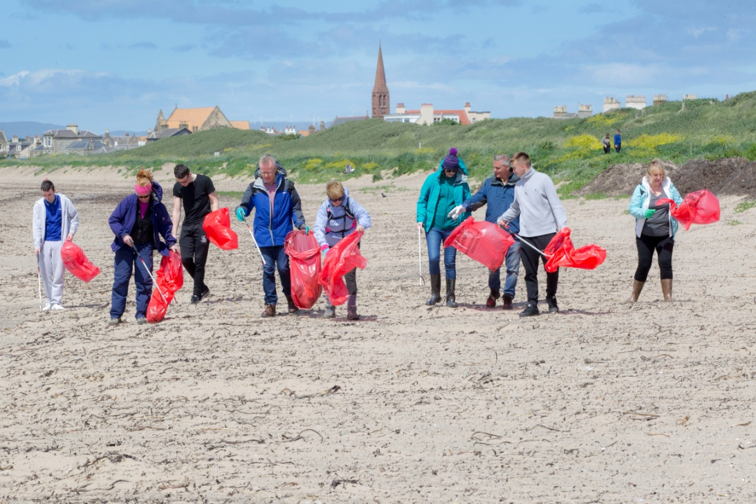
- Almond Valley - including ground works around a new orchard picnic barn and moving a bird house
- Forest Maintenance with Forestry Commission

Encouraging Biodiversity in our Offices
Our Dumfries office have been piloting some biodiversity projects including planters in the office garden areas and commissioning the building of a bird box made from local sustainable materials for the office garden areas. Following the success of this pilot we will encourage other offices to think about how they could best promote diversity in their grounds.
Infrastructure Projects
As part of our development at Edinburgh Bioquarter the Water Feature which has been installed in the site encourages biodiversity.
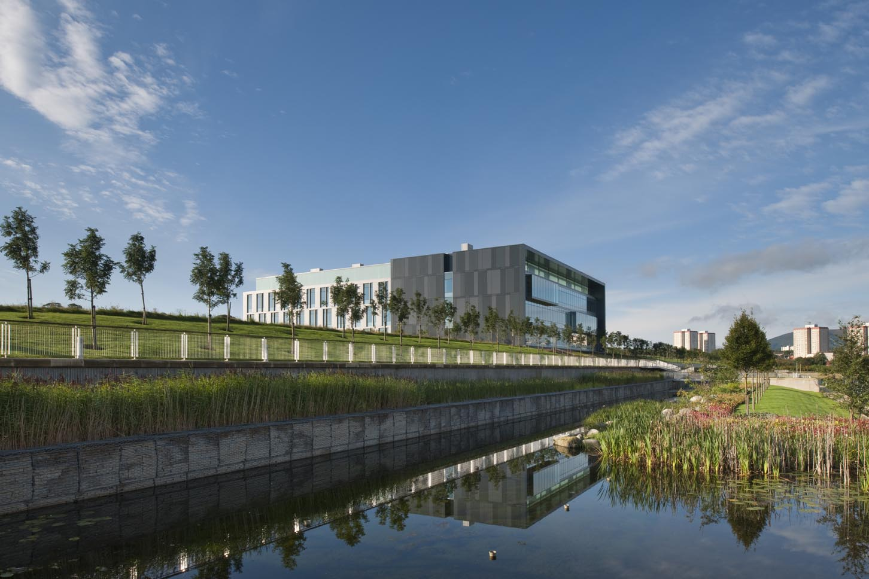
The 0.5 km long feature has two levels, the higher level provides attenuation of surface water from the southerly plots before discharging into an adjacent SUDS pond.
The lower level acts as a feature with fountains at either end, and is planted with oxygenating plants and shrubs which provide a nesting / resting place for local birds and ducks including a couple of Swans which have been frequent visitors.

Section 4: Partnership working and biodiversity communications
We have recently started working with Scottish Natural Heritage to refresh our Biodiversity Statement and identify areas for development in the next 3 years. The statement will be published in February 2018.
Scottish Enterprise, together with Forestry Commission Scotland and Scottish Natural Heritage, remains a member of the charitable company Central Scotland Green Network Trust. The Central Scotland Green Network is a national development priority within the National Planning Framework, encompassing 19 Local Authority areas across 10,000km² and with the potential to benefit 3.5 million people by enhancing their access to and enjoyment of greenspace and the natural environment. The Trust provides strategic co-ordination to public agencies, voluntary sector stakeholders and local community groups to align their policies, programmes and actions to achieve common goals around five core themes:
- Creation of greenspace and green infrastructure within urban environments.
- Permanent naturalisation or temporary greening of vacant and derelict land.
- Supporting community growing schemes (gardens, allotments and orchards) particularly in areas of deprivation.
- Supporting development of Active Travel routes through green corridors.
- Increasing the provision and quality of wood, grass, heath, peat and wetland habitats, supporting carbon sequestration and sustaining flora and fauna biodiversity.
Scottish Enterprise also sits on the Scotland Food and Drink and the Scottish Tourism Alliance Sustainability sub-groups.

Section 5: Biodiversity highlights and challenges
We are currently developing our Biodiversity Statement for the next three years. This will focus on our people, our property portfolio and the companies/sectors we work with.
The Scottish Enterprise climate change group have identified many opportunities to get colleagues more involved in activities which promote biodiversity at work and at home. Future activities will include a communication campaign which will make the links between biodiversity and climate change and health and well being.
There are opportunities to do more to promote biodiversity within our property portfolio, our Business Infrastructure team are currently investigating ways to do this.
A key challenge is how to encourage companies to think about biodiversity as part of our role in promoting innovation and business efficiency. We plan to work with partners to develop case studies of the business benefits of biodiversity to help us to do this more effectively.

Section 6: Monitoring
Low carbon is a cross-cutting opportunity across the four drivers of economic growth identified in our Business Plan.
Two of our 15 Business Plan measures have a particular low carbon focus.
Our progress against these measures is detailed below:
Business Plan Measure | Target 2015-2016 | Achieved | Target 2016-2017 | Achieved | Target 2017-2018
540,000 – 660,000 tonnes of planned CO₂ savings arising from SE company support and large scale, innovation led projects | 160,000t – 200,000t | 200,796t | 180,000-220,000 tonnes of CO₂ | 204,446t | 200,000t – 240,000t
Business Plan Measure | Target 2015-2016 | Achieved | Target 2016-2017 | Achieved | Target 2017-2018
£300m – £360m of planned efficiency improvements by supported companies | 90m - £110m | £113m | £100m - £120m | £117m | £110m - £130m

We support companies and sectors through a range of activities including business and export advice, innovation support, access to finance, demonstration projects, supply chain development and through targeted infrastructure to support the growth of low carbon sectors.
SE does not track any biodiversity trends or indicators as part of its measurement framework.
Jan 2018

