

Networks:
A Best Practice Guide

Report for Scottish Enterprise

March 2011

EKOS Limited, St. George’s Studios, 93-97 St. George’s Road, Glasgow, G3 6JA
Reg 145099

Telephone: 0141 353 1994
Web: www.ekos-consultants.co.uk

Direct enquiries regarding this report should be submitted to:
Madeline Smith, Head of Innovation, EKOS
Email: madeline.smith@ekos.co.uk
Tel: 0141 353 8319

 As part of our green office policy all EKOS reports are printed double sided on 100%
sustainable paper.

Contents
1. Introduction 1
2. Strong Purpose 2
3. Leadership and Ownership 3
4. Measuring Networks 5
5. Summary 8

Introduction
The role of networking has long been seen as a useful tool in allowing businesses to explore new ideas, find new customers and suppliers, share knowledge and collaborate.
As the world of business becomes ever more dynamic and fast moving, changes in innovation approaches suggest that working collaboratively with other organisations is a more effective strategy. Companies which look outside their in-house resources have better access to ideas, expertise and technology than those that rely solely on in-house sources.
This has led to a recent paper from the Economist Intelligence Unit to claim “the future belongs to those who collaborate....with many players, from customers and partners, to competitors, distributors and university researchers”.

Objectives of this Guide
Developing and supporting business networks can help organisations find such opportunities, and as such, over the years, Scottish Enterprise (SE) has developed an interest in a wide range of networking projects and programmes.
Networks can cover a whole range of activities including sectoral groups, trade associations, clusters, or geographic networks.
However, just bringing organisations together in the hope that innovation and growth will happen is clearly not sufficient.
This guide has drawn together experience from previous research and practice, both in SE and elsewhere, to highlight some key elements to consider when working with networks.

Strong Purpose
The first thing to consider when developing or supporting a network, is why has that network been formed? Networking is only a means to achieve something, not an end in itself.
What are the organisations involved hoping to achieve, and how do SE’s objectives fit with that ambition?
Is there a strong strategy with tangible outcomes? Are all members of the network signed up to that agenda? How will it be achieved?
The more specific the objectives of the network, the more clearly it can be shown to have made progress. In addition, this can also help to attract new companies to engage.

Return on Investment
There is a misconception that networking is free. However, it does involve considerable investment in time from the participants.
Companies will only network and collaborate for a good commercial reason. As such the companies have to see the return from that investment. According to collaboration experts Jeff Shuman and Janice Twombly of the Rhythm of Business, the benefits of such collaboration needs to be recognised where:
Benefit of Collaboration = Value of resources leveraged
Time & effort to collaborate
This may not necessarily be immediate financial returns, but could be more intangible benefits. However, the network must be viewed as adding value.
As well as direct sales improvements attributable to the network, companies also cite a number of wider strategic benefits, including:
- improve market intelligence and understanding
- new networks and supply chain links have been established
- new business activity and new markets
- access to better information available
- influence with government;
- development of coherent industry strategy; and
- improved profile of the industry.
With a strong purpose and real returns for the organisations involved this helps maintain a strong network which is delivering for its participants.

NOF Energy
NOF Energy is a networking and business development organisation for businesses operating and involved in the oil and gas and related energy sectors in the North East of England.
Part funded by One North East (ONE), it is a membership organisation that delivers a range of events, exhibitions, marketing, international trade activity, business to business and other services.
Their aim is to assist member companies in accessing and securing contract opportunities, as well as building their knowledge of the global oil and gas markets and increasing their business profile, with a particular focus on improving business performance.
A recent evaluation highlighted that over the past three years they have delivered 120 separate events and have engaged with around 3,000 businesses. NOF services were perceived to be valued by their members. Most importantly, companies reported new sales/contracts of £17.85 million, showing that there has been a real return on investment for the companies involved.

Leadership and Ownership
Many networks, although supported by the public sector, strive to be industry led. Many times this involves the steering board being drawn from local industry, and even having a strong recognisable and credible leader from industry.
Practice shows that this is important in establishing a network that is focused on business needs and addressing issues relevant to the companies involved.
Unless there is an ownership from industry to drive the network, once public sector support is withdrawn it is unlikely that the network will survive in the longer term.

Role of Brokerage
For a thriving network, and especially at the early stages of establishment, the role of a facilitator can be extremely important.
This brokerage role helps build the trust and establish relationships necessary for ongoing collaboration.
The facilitator can be proactive in identifying areas of interest for the participants, and bringing together relevant parties for potential collaboration. They can also act as a neutral figure acting on the collective behalf of the network, especially when normally competing companies are engaged.
BSR Transnational Pilots
The Baltic Sea Region (BSR) is piloting opportunities to network some of the clusters across the different countries in transnational pilots.
Different clusters or innovation networks have started to identify joint agendas and actions they could work on together more successfully.
Networking and clustering takes time since relations have to develop. As one cluster manager put it: “It’s a people thing, and people are getting to know each other. Collaboration takes place between people, and they have to be able to relate to one another. When creating links between clusters in the BSR, it is important to build trust from the very beginning.”
The role of the network facilitator (a trusted figure from each cluster) in establishing these broader collaborations is proving to be extremely important.
Because of the success of these initial pilots, BSR has now extended this to a further transnational collaboration programme.

Network Renewal
In more established networks, there is the need to keep the membership refreshed, to ensure new ideas and perspectives keep feeding into the discussions.
While there is certainly an initial stage of trust building before participants are comfortable with working together, over a period of time there is a danger that the network becomes too comfortable, and therefore no longer innovative.
Studies have shown that for an innovative network to continue to thrive there needs to be a balance between co-operation and competition (this is sometimes referred to as “co-opetition”).
There is also a need to review the role of the public sector. Initially this may be about helping to establish and stimulate the network. As the network matures the role may change to supporting specific projects or activities.

Measuring Networks
One of the challenges with working with networking as a business development tool, is that it is often perceived as the softer side of activity, and more difficult to measure the impact of the involvement of SE. Hence it can be challenging to provide the evidence to justify continued involvement.
For that reason, measuring the impact of the network is extremely important (although not necessarily an easy task).
There are a number of ways to measure the impact of the network, and possibly a combination should be used to gather a wide range of evidence.
- Why the network?
What was the network trying to achieve and how effective has it been in achieving those goals? If the purpose of the network was clearly defined, progress towards those achievements can be tracked.
- Overall impact?
Networking is a means to an end, and from a business development point of view this should ultimately lead to business growth, greater productivity, new products and processes and other tangible performance improvements. These can be tracked from the participating companies, and an assessment made of the contribution of the network to this improvement (would it have happened in the same way, or at all without the network?).
- What was done?
As an interim measure networks often monitor the number and type of events and activities, and the level of participation. While this is useful to show company engagement, and even growing numbers of members, it nonetheless fails to show the difference the network has made. As such it is useful information but only alongside other data.
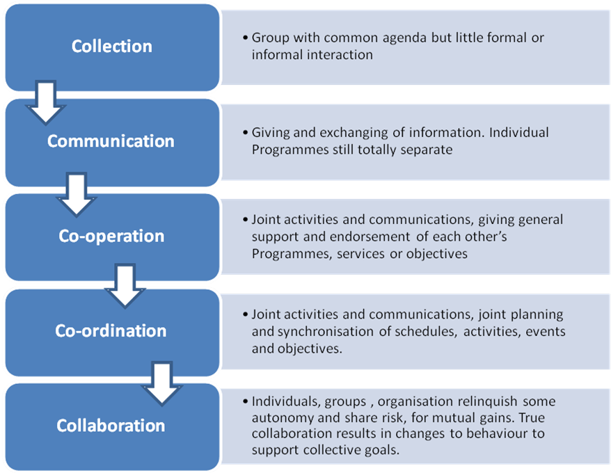
- How has it worked?
The fundamental approach of networking is to build trust and therefore allow new and deeper relationships to be established. Capturing the progress of that development, from being just a collection of companies with little or no relationship, to ones who start cooperating, and then leading to more collaboration is a useful way to “tell the story” of how the network has developed.
An example of such a journey is shown in the model below.
Figure 1: Partnership Journey

- What else?
Looking at the wider impacts of the network, for example how it has helped build critical mass, or showcase the expertise in the region and helped build reputation, are useful additional impacts from networking that demonstrate how the whole is greater than the sum of its parts.“Together we can create more shared value to benefit us all”.

Scotland Food and Drink
A recent study on Scotland Food and Drink (SF&D), highlighted the progress along the collaborative partnership as a key element of the evaluation. Scotland has a wealth of strong businesses across the food and drink sector. However, the sector has been characterised by fragmentation. SF&D was established to help bring the different parts of the sector together, across the different subsectors (red meat, dairy, whisky, etc.) and from primary producers to processors and distributors.
The evaluation of their progress used the above model to show how the organisation had succeeded in bringing the sector together under a unifying umbrella, developing a joint strategy and delivering a joint action plan.
Assessing the progress of the partnership approach, it could be seen that good progress had been made. The organisations started the process as a collection, all of whom worked in the food and drink sector in Scotland, but many of whom had not even met. Communication was shown to have improved, with better exchange of information and advice. There was evidence of co-operation - signposting and publicising each other’s events, some joint events, and working together on common agenda items, such as branding and international profiling. Co-ordination was also evidenced, including planning events so that there are fewer but better events in the food and drink calendar, attending conferences and shows under the one international pavilion, and working together on joint funding bids. As such the cluster has shown significant progress by moving from a very fragmented sector, to one where there is a shared strategy and action plan.
However, at this stage there was less evidence of deeper collaboration where resources are pooled and objectives are jointly pursued. This analysis was then used to stimulate discussion at the SF&D board, where it was agreed that when moving to delivery of the action plan, developing deeper collaboration is an essential next step.

Summary
This guide has gathered good practice thoughts from studies and experience in working with innovation networks to stimulate growth.
Key points to consider when working with networking programmes are:
- establish a strong purpose for the network with which all participants can engage;
- companies have to see a good return on their investment to continue to be involved;
- ensure a strong industry ownership for the network, to help drive the agenda and build credibility;
- the role of the facilitator in brokering new relationships and helping to build trust is extremely important;
- continually refresh the members of a network to make sure it keeps an innovative edge; and
- measuring success, whether the achievement of objectives, tangible business benefits, or the progress on the collaborative journey, all help to show the benefit of networks.

Economist Intelligence Unit (2007), Collaboration: Transforming the way business works , April 2007
Model used in SF&D Evaluation, 2010, Adapted from Corbett and Noyes (2008)

