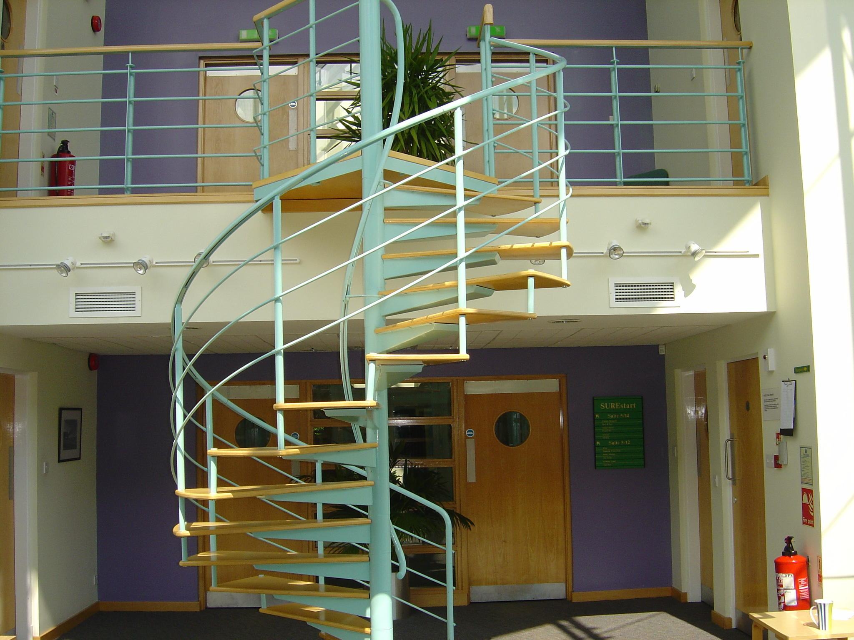

Student Enterprise Incubator – Scion House

An Interim Evaluation (June 2005)

Scottish Enterprise Forth Valley

Chapter 1

Executive Summary & Background

Introduction

This document presents the findings of an interim evaluation of the Student Enterprise Incubator (SEI), Scion House, The University of Stirling, which was undertaken during June 2005. The assignment was requested by one of the SEI funding partners, Scottish Enterprise Forth Valley (SEFV) and supported by the management company Stirling University Research and Enterprise (SURE) Ltd.
Key Findings

The invitation to tender set out a number of objectives to be achieved through undertaking the evaluation, these and the consequent findings are outlined below:
- The total financial contribution towards the incubator since 2002

As can be seen from Table 1, Scottish Enterprise Forth Valley funding has provided £ 50 000 representing from 17% to 28% of total project funding over the three years of the project. However, the accounts for 2004/05 show a total funding requirement of £ 117800. This discrepancy could be explained by use of the ERDF funds and the links within the overall Student Enterprise Programme but we do not have the information to confirm this.

Table 1 – Financial Analysis
Financial Year | Funding Required | SEFV Funding | SEFV Funding% | ERDF | SIE
2002/2003 | £54,378 | £9,000 | 16.6 | NA | NA
2003/2004 | £67,165 | £18,000 | 26.8 | NA | NA
2004/2005 | £64,580 | £18,000 | 27.9 | £60,604 | £35,000
2005/2006 | £0 | £5,000 | 0 | 0 | 0
Total | £186,123 | £50,000 | 26.9 | £60,604 | £35,000

- The number of students that have sought the advice from the incubator

There are 9000 potential student entrepreneurs at the University in any academic year. The marketing communications programme of marketing generates an average 350 enquiries per annum with 100 of these going forward to the Enterprise Programme in some format. There are no figures available for the period prior to this, although anecdotal evidence would suggest that rate is less far less than 350 enquiries. If we assume the best possible case then the number of students who have sought advice from the outset will be up to 1000.
- The reasons above students have not take up an incubator place

It was not possible to speak directly to student who have not taken up the incubator space. However the consultation with the SEI Manager has suggested that the lack of engagement was down to the timeliness of the intervention (i.e. the student may re-engage later) and the student having sufficient resources to launch without the support of the incubator.
- The number of student incubators housed since 2002 and the number who have become start-up companies

Since 2003 SE Manager and his team have helped students evaluate 42 business concepts. In addition since start up the SEI has housed 18 start-ups of which 13 continue to trade. There is a pipeline of 6 potential entrants.
- Perceptions of 5 current incubators on experiences of the incubator and what they would have done without the support on offer

The incubatee perceptions are outlined later in Figure 7. The key finding is that the incubatees believe that SEI has delivered its promise and that without it the projects may have gone ahead but not to the same extent or timescale.
- The nature of the student incubators, e.g. sector, graduate, post-graduate

2 of the businesses were run by postgraduate students, 2 by graduate students and one by a pre-graduate student.

- The scale of student incubators: no. students and turnover

All of the businesses were in the Service sector, although 3 were involved in the software development to support the business model. The natures of the ventures are: Social Enterprise, Language Training, Translation Services, Event Management, and Sport Events.
- Any potential economic outcomes

  - All five incubator companies cited benefits from being involved with the SEI. This related to the ability to transition through the difficult early growth stages of a nascent enterprise – this risk management could improve both the survival rate of the enterprises and the scale of the resulting business. In terms of additionality, this limits the benefit to ‘timing’ or ‘scale’ and this has a significant influence on the overall impact.

  - The clearest measure of additionality relate to employment and business turnover.
    - The survey sample indicated that there were a total of 5 people employed by the ventures before entering the incubator and 11 during or after entering the pre-incubator
    - The combined turnover of the sample had increased by £ 210 000 per annum since entering/leaving the pre-incubator

  - Displacement is a factor with related services being offered by other Universities and Institutions within Scotland. The level of this is low as in reality these Universities and Institutions would not be in competition with each other for the pre-incubator clients. There was a pre-incubator ‘graduate’ in the sample and their presence could be at the expense of other local public and private sector incubators.

In terms of benchmarking the incubator has a survival rate of 72% (no. businesses trading/total no. of business started 2003 to date). A recent study by the Oxford Trust has shown that more than 3 in 4 of UK incubator start-ups are still in business after five years in comparison to 1 in 3 of non-incubated companies. On this basis the SEI is near average. However, this needs to be qualified by the fact that the time horizon is just over two years for SEI and that the use of external support can increase the survival rate to 90%.

There was not a requirement for a formal economic impact assessment within this interim evaluation. However our consultations have identified that the SEI does play a role within the Forth Valley business start-up framework. Its contribution to date relates to it ability to control the risks linked to early stage ventures and in transferring skills and experience to novice entrepreneurs.

When the SEI was established it was based upon the two existing Scottish incubators with similar structures and objectives. It is interesting to note that one of these – Robert Gordon University Incubator is no longer operating, whilst the University of Abertay continues to operate but with closer links to the local economic development infrastructure.

Background

Student Enterprise Incubator

A commercialisation strategy for Stirling University was prepared by Stirling University Research and Enterprise (SURE) with Scottish Enterprise Forth Valley (SEFV) input in 2001. This strategy identified that there is a latent potential of both staff and students to start new businesses and a pilot project ‘Enterprise on Campus’ (involving University of Stirling and Falkirk and Clackmannanshire Colleges) was run in 2001 to explore business start-up with final year undergraduates and post graduate students. This project clearly demonstrated that there was a market that the existing Small Business Gateway was not directly addressing.

This market gap related to the provision of a supported environment within the University to help students (and potentially) staff to understand more about business start-up, help identify opportunities, provide a space for embryonic businesses to grow and provide the necessary links into the Small Business Gateway.

The business model chosen to address this gap was based upon two other Scottish student enterprise models – one at Robert Gordon University in Aberdeen and the other the University of Abertay in Dundee. The Stirling Model was differentiated by the stronger links into the existing business support network – (Small) Business Gateway. The model had three key strands: training, advice and mentoring utilising SURE staff and the Small Business Gateway; financial and business support for the Stirling University Student Association (SUSA) Business Club; and the provision of facilities for business start-up capitalising on the links with existing entrepreneurs.

The training, advice and mentoring were intended to be run through a combination of workshops targeted at first and second year students. The workshops would feature young entrepreneurs and enable the students to form a view as to whether self-employment/business start-up is for them. A second series of workshops would focus on practical business start-up issues and potentially lead to an appointment with a (Small) Business Gateway start-up advisor. There would also be one-to-one confidential clinics drawing on the (Small) Business Gateway expertise, as required. Support for the SUSA Business Club is critical as it would enable the potential entrepreneurs to access a supportive network of peers. This club belongs to and is run by the student body. SURE’s involvement relates to behind the scenes support.

SEFV would be a partner in the project both through its funding of the (Small) Business Gateway and also through funding of the pre-incubator facility at Scion House, University of Stirling. The aims of the pre-incubator were:

To provide a facility that would help students distance themselves to some degree from the University campus whilst maintaining vital personal networks.

To provide business support facilities in common with those already provided to tenants of Scion House.

To provide a fixed term home (1 year) for fledgling businesses after which aftercare would be provided by the (Small) Business Gateway to endeavour to ensure the businesses remain in the Forth Valley area.

There would be no direct funding support through the pre-incubator as the students would be expected to access available resources such as SBG, PSYBT and the Banks, however they will be offered rent/rates free accommodation and be re-charged by the University, for telephone charges and other services provided to them by Stirling University Innovation Park (SUIP) Ltd.

SEFV’s financial contribution related to the rent of Suites (14 and 15) within the Software Centre at Scion House. This funding would cover the £22 per square foot all-inclusive charge (less 80% rates relief due to the University). This arrangement was designed to ensure that the University pays a market rent for the premises and Scottish Enterprise receives an income. The incubator started operation in financial year 2002 – 2003.

The SURE Perspective

The following paragraphs have is taken from two documents - a programme to promote and support student Enterprise (SURE/SUSA/SUSA Business Club) and the Student Enterprise Marketing Plan – and from discussions with Alasdair Gammack the SURE Student Enterprise Manager.

It is important to understand that Student Enterprise Programme is not a stand alone entity but part of an overall Student Enterprise Programme. The Student Enterprise Programme is ‘…part of the overall commercialisation strategy for the University of Stirling, (as part of this) the SURE Team wishes to encourage, assist and support the development of an entrepreneurial atmosphere throughout the entire student base…those able to demonstrate entrepreneurial flair, coupled with realistic ideas will receive SURE support through a step-by-step support programme designed to enable them to evaluate, develop, present and exploit their business idea in the best possible manner and with the greatest chance of commercial success…SURE…expects to tap into local support resources to supplement its own activities’

The Student Enterprise Programme is designed to ‘evangelise to the student body on enterprise’ more specifically to:

Advocate and promote active participation in SURE initiatives for students designed to increase understanding of business and to help identify opportunities

Assist in creating and generating a number of start-up enterprises based upon student’s ideas and relevant course activity and study areas

Establish some 3 – 5 successful student owned start-up enterprises within the pre-incubator within 30 months

Support and assist SUSA members in establishing the Business Club

The target audience for the overall programme was 6400 undergraduate, 1400 postgraduate students. The marketing plan states that by the end of 2002/3 80% of all students would know that the programme and its services/facilities exist

The strategy adopted was to offer a ‘step-by-step’ framework that would be flexible enough for students to choose the components that are relevant and useful to their stage of study. This framework would include training, advice and mentoring (3rd option conferences, Into Business – Information Workshops, Business Clinics); support for the SUSA Business Club (now named Venture Club) and provision of facilities for embryo business start-up (the Student Enterprise Incubator). Since 2003 students have also been eligible for the SURE Innovation Awards

The SEI would make use of unused units in SUIP, be fully serviced and costs of rent, rates, servicing, electricity, telecommunications, basic equipment and secretarial support would be provided, on a free of charge basis, by SURE.

From the outset it was the desire to work closely with the Careers Service at the University and to co-ordinate the Student Enterprise Programme with broader careers development programmes.

A full time Student Enterprise Manager (Alasdair Gammack) has been in place since January 2004; prior to this the role was assumed by a student ‘secondee’ – the Student Enterprise Coordinator - Nick Telford. The Student Enterprise Manager draws upon the support of two student interns (funded by the Scottish Institute for Enterprise), the SURE Marketing Manager (Kate Wooding), the SURE Contracts Manager (Eric Gibb) and part time business advisors (e.g. Malcolm Bateman).
Space

Since the outset the SEI has occupied two units within the Software Centre at Scion House. These are open plan office spaces and initially these were Units 14 and 15. Another unit has since been adopted to give increased capacity although the SEI still has informal access to the vacated office (currently used for storage). The incubation space was designed to accommodate up to 12 companies with 6 in each office. There are currently 10 incubating ventures. There are 8 pre-incubator clients and two graduate companies in the space (Global Voices and Firefly IT). The graduate companies pay a charge of £630 per quarter as well as being liable for telecommunications and consumables charges.

Services & Facilities

As mentioned in paragraph earlier the pre-incubator aims to support for student entrepreneurs and to increase success rate of resulting businesses. There are three dimensions to the services and facilities provided:

Rent/rates free fully serviced office space/equipment (for up to 1 calendar year)

Advice and mentoring from experienced advisors

Networking and experiential learning through structured events
Report Structure

Chapters Two and Three represent interviews with the project management team and a sample of current incubated ventures. It is followed by Chapter Four which details of the analysis, conclusions and recommendations. It is followed by an Appendix A presenting background information on comparative benchmarks.

Chapter 2
Consultation with Project Partners

Introduction

Three groups were consulted as part of the review:

Scottish Enterprise Forth Valley

SURE Limited

We summarise the views of each of these groups below and we also draw out issues that emerged during these discussions that are common across the groups.
Background & involvement with SEI

Although it was only formed in 2002 there have been significant changes in staffing of the SEI. This and the changes in responsibilities at SEFV, has resulted in an information fragmentation and the consequent problem in a seamless view of the SEI history.

It is also important to understand the diverse nature of the SEI funding. There is EC funding through the ERDF, Scottish Institute for Enterprise funding for the SEI Manager and two student interns and University funding through Knowledge Transfer Grants in addition to the funding from SEFV. The breakdown for the last financial year was: ERDF (£ 60 604), SIE (£ 35 000), KTG (£ 4196) and SEFV (£ 18 000).

Inception Meeting

This meeting was attended by both SEFV and SURE personnel. The aim was to determine information requirements and to put the SEI in context.

The first issue raised was that SEI should not be viewed in isolation but rather as part of the overall Student Enterprise programme at the University of Stirling. As such the incubator should be viewed as a ‘pre-incubator’ as much for the development of entrepreneurial processes and attitudes as it is for the development of businesses.

It is also important to appreciate the University is not focused on science and technology and so does not have a high level of high technology (high growth) spin-out activity.

Although the quantitative aspects of the SEI’s performance are crucial (companies formed/processes developed), qualitative factors such as attitudes and motivations of the incubatees are equally important.
SEI Manager

The discussions with the SEI Manager (Alasdair Gammack) took place on 20 and 22 June.

The Student Enterprise Programme emerged form both the University’s commercialisation strategy and as a response Scottish Enterprise’s recommendation of 2002 that ‘…Scotland’s performance in producing start-up businesses remains poor… (we) must improve the levels of entrepreneurship produced by the education system…’

The Entry Process

The main criterion for entry to the SEI is that the candidate should be studying at the University of Stirling (graduate or postgraduate) or should be within 3 months of graduation. There are no other set criteria, however the SEI Manager does attempt to maintain a balance in the types of ventures hosted to ensure balance, reduce potential competitive conflicts and allow time for providing advice and support.

The recruitment of potential incubatees is a multi-track process involving advertising on campus, presentations (informal) to students during lectures, a weekly ‘stall/surgery’ on campus, promotion through the Student Venture Club seminars and networking events and presentations by the SEI Manager at various conferences.

The recruitment results in an average 350 enquiries per annum with 100 of these going forward to the Enterprise Programme in some format. However these figures relate only to the period in which the SEI Manager has been in place. There are no figures available for the period prior to this, although anecdotal evidence would suggest that rate is less than 350 enquiries. Allowing for an equivalent level of interest would suggest that the total number of student’s enquiries would be less than 1000.

There are perceived to be a number of reasons for non engagement with the SEI or the Enterprise programme prime among which are timing and self-sufficiency.

The potential incubatees have to submit a pre-incubator application form to SURE. This 2 page form contains student details along with information on the business idea, its market, the business management, financial projections, key milestones and a statement of what the potential incubatee requires from the pre-incubator. This application is then assessed by a selection committee chaired by the SEI Manager. Current members include Frank Dunn, John O’Mahoney, Professor Rob Ball and Jovo Ateljevic. They will asses each proposal against market demand, realism of idea, objectives, management and business vision. The SEI Manager will then ensure that the balance mentioned in 3.11 is maintained. To date there have been no applications that have failed.

Facilities and Support

When selected the incubator venture (subject to signing of formal contract) then has access to open plan office space (typically occupied by another 5 ventures), a telephone, PC, a business address and administrative and business support. There are currently 12 businesses in space that could be occupied by up to 14 enterprises.

The SEI Manager can also call upon the support of two student interns (funded by the Scottish Institute for Enterprise) who have the prime responsibility of interfacing with the student body. The Manager also has the support of other SURE staff for marketing and legal issues as well as part-time business advisors.

Services

There is a structured programme of events and seminars through the Venture Club. This programme is targeted at the student body but has recently been opened up to local companies and in so doing meeting a requirement of ERDF finance.

This outreach is also being extended through the SEI Manager other work e.g. facilitation for Cambridge-MIT Institute, hosting students from Columbia University at Napier University this summer and acting as a ‘mentor’ in the Clackmannanshire Business Liaison Initiative.

Consultations with the incubator enterprises are also used to signpost the incubatee towards the Business Gateway network and the PSYBT for funding and other support.

The SEI Manager is currently in discussion with the University about adding a credit bearing course in enterprise skills to the undergraduate curriculum. This would have the benefit of formalising an ad hoc and informal process of lecture presentations and increasing the number and quality of potential ventures.

There is no formal ‘graduation’ space at Scion House (although two companies are still using the pre-incubator). It is hoped that the Kilncraig Incubator could be made available for this.

Metrics and Recording

Whilst there are criteria for entry and for assessing effectiveness of measures these are relatively few and much of the operational development and assessment is dependent upon the judgement of the SEI Manager. There are financial projections and budgets but there are no systems for recording number of interactions with students and other and the details of any discussions. There were such systems in the first incarnation of the Enterprise programme – however the extent to which they were used is debatable.

Chapter 3
Interviews with Incubated Companies

Interviewees

This chapter presents details of our incubatee survey findings. The survey included interviews with 5 of the 12 SEI incubator companies (both former and current). These ventures were: GilmoreLynch Ltd., Fivez Ltd., Global Voices Ltd., Quit & Save Ltd., and LaClave.
Business and Management Profiles

All of the businesses were in the Service sector, although 3 were involved in the software development to support the business model. The natures of the ventures are:

Social enterprise offering smoking cessation services

Delivery of Spanish language courses

Golf event management

Community based 5 and 6-a-side football leagues

Translation and interpretation services

Two of the businesses were run by postgraduate students, two by graduate students and one by a pre-graduate student.

Prior to entering the pre-incubator, all five interviewees had work experience other than vacation employment.

Each of the interviewees was asked why they decided to enter the programme and the SEI. The results are represented on Figure 6. The highest percentage of ventures cited having an idea they wished to pursue as the reason for entering – an interesting finding as it is the opposite of the experience of other incubators such as the LMU (see paragraph 2.7). The desire to stay in the local area or linked to the University and the desire to gain skills are also a powerful influences. Financial gain was only cited by two of the interviewed incubates.

Figure 1 – Why did you decide to enter the programme/incubator

All the interviewees viewed the pre-incubator as being the first step in entrepreneurial ladder and they aimed to use it to gain support from experienced professionals and minimise start up risk. They all believed that being in the incubator gave the business credibility both in terms of the address and the implied endorsement of being accepted onto the programme.

Centre and Services

4 of the 5 incubators became aware of the SEI through ‘word-of-mouth’ contact with colleagues at the University. 1 mentioned direct contact from the University/SURE and as referrals from the Business Gateway/STEP.

The initial reasons for approaching the SEI were, in order, recommendation of business advisor, availability of premises/support, possibility of grants (even although these are not directly on offer) and the chance to obtain a business address.

Only one of the interviewees looked at competing facilities. They decided upon the SEI because of proximity to home and the enhanced support package on offer.

In terms of the total SEI package the rankings of the most important factors were – business advice and support, the property and the location.

In terms of the physical space (see Table 1) the most valuable asset was seen to be the availability of meeting space followed by common meeting/networking areas. The latter is probably reflected in the value on moral support from other firms. An issue of concern was the lack of disabled access.

Table 2 – value of physical space
 | Some  value | Significant  value
- Modern image of building – external | 5 | 0
- Access the University and staff | 1 | 1
- Access to meeting rooms | 1 | 3
- Access to on-site facilities | 3 | 1
- Common meeting/networking area | 3 | 2
- Moral support from other firms | 3 | 1
- Admin support | 1 | 0

The interviewees felt that the physical space had a medium impact on getting their business where it is now.

All the incubatees have received advice and support from the SEI staff in four key areas: mentoring, sales/marketing, finance and legal (contracts). On a scale on 1 to 10, (10 being excellent and 1 very poor), this advice was rated at 7 or above. There were only two instances of scores less than this and these related to the IT infrastructure/firewalls and business planning.

All of the interviewees viewed the business advice as having a significant impact in getting their businesses to where they are now.

All of the companies have used the presence in the SEI to have business discussions with other incubatees and 3 companies have also used it to have similar discussions with other tenants of Scion House.

A retrospective analysis highlighted that the original (prior to entry) assessment of the SEI was valid during and after ‘graduation’ – it delivered the promise.

3 of the companies said they are planning to leave the SEI and 2 of these companies would value the availability of graduation space. This graduation space would be valued by the 2 other companies – all cited cost of this space being a critical factor.

A final analysis of the perceived benefits on being involved in the incubator is given in Table 2. The greatest impacts have been in enhancing business knowledge and in product development.

Table 3 – The benefits of being involved with SEI
 | No Influence | Some Impact | High Impact
Enhanced business knowledge | 0 | 2 | 3
Improved market knowledge | 4 | 0 | 0
Access to new forms finance | 1 | 2 | 2
Better understanding planning | 1 | 1 | 1
Protection of idea/product | 0 | 2 | 1
Links other firms | 0 | 3 | 1
Links University(s) | 1 | 1 | 2
Product development | 0 | 2 | 3
Developing skills of staff | 0 | 3 | 1
Other | 0 | 0 | 1

When asked if they would recommend the SEI to other students all the interviewees said yes. The reasons being ‘a good place to do business, ‘gives credibility’, ‘moral support of other incubatees’ ‘continuity of support’ ‘location, advice and support’

Additionality & Displacement

Additionality is the extent to which a firm would have undertaken an identical activity without public assistance – if the firm brought the project forward in time, enlarged its scale or improved its quality as a result of the assistance; these benefits would have to be taken into account.

All five incubator companies cited benefits from being involved with the SEI. This related to the ability to transition through the difficult early growth stages of a nascent enterprise – this risk management could improve both the survival rate of the enterprises and the scale of the resulting business. In terms of additionality, this limits the benefit to ‘timing’ or ‘scale’ and this has a significant influence on the overall impact.

The clearest measure of additionality relate to employment and business turnover.

The survey sample indicated that there were a total of 5 people employed by the ventures before entering the incubator and 11 during or after entering the pre-incubator

The combined turnover of the sample had increased to £ 210 000 per annum since entering/leaving the pre-incubator

Displacement is a factor with related services being offered by other Universities and Institutions (e.g. University of Abertay, RGU and SEI) within Scotland. The level of this is low as in reality these Universities and Institutions would not be in competition with each other for the pre-incubator clients. However there was a pre-incubator ‘graduate’ in the sample and their presence could be at the expense of other local public and private sector incubators.
Perception study

It was requested at the inception meeting that contextual information be gathered to give a fuller understanding of the SEI and its interactions with the Student Enterprise Programme and the potential for further development.

To this end we used a perception ‘radar’ diagram to determine key issues and relativities. The right hand side lists services offered by the SEI and the left services that have been found to be important in other studies of student enterprise initiatives. The questioning asked:

Prior to entering the incubator how important did you perceive these factors to be (0 to 50 scale, 50 being highly important)?

In reality (now) how important are these factors (0 to 50, 50 highly important)?

The radar diagram shows four key dimensions – axes on the right-hand side show the services provided by the SEI; the left-hand side services that could be provided; the dark blue area shows the interviewees perceptions before entering the SEI; the thick black line their perceptions after having entered the incubator.

Figure 2 – Perception Radar (Aggregate)
0
10
20
30
40
50
SU Links
Rent/Rates
Advice
Mentoring
Facilities
Other Incubatees
Location
Start Up Finance
Advice Other
Mentoring Other
Customers
Incentives
Skilled People
Supply Chain
Services not provided by SEI
Services provided by SEI
Perception after incubation =
Perception before incubation = dark blue

The analysis was carried out for all the interviewees and an aggregate diagram produced. Please note that these are perceptions and are not statistically significant analyses. It shows that:

The SEI services meet most of the perceived and actual requirements with the only issue not address being the availability of skilled people for the ventures

The reality of importance (solid black line) shows that the main gap in SEI service lies in mentoring and to a lesser degree advice and facilities

The proximity of other firms/incubatees is less important than expected

We return to these and other issues when drawing our conclusions in the next chapter.

Chapter 4
Analysis, Conclusions & Recommendations

The SEI has had four major funders – ERDF, The Scottish Institute for Enterprise, The University of Stirling and Scottish Enterprise Forth Valley. The main sources for information have been a source and application of funds statement for 2004-5 provided by SURE, The SURE/SUSA paper on the programme for promoting student enterprise and the SEFV Chief Executive Paper – Enterprise Incubator, Scion House of 2002. We have still to receive statements for 2002 and 2003 from SURE.

Contribution

The contributions of all the funding partners are given in Table 3. The key points to note are:

The SEFV funding has represented between 17% to 28% of total project funding

The funding requirement as stated in the SEFV Chief Executive paper and the SURE/SUSA document is for £ 186123 over the three years of the project. However the accounts for 2004/05 show a total funding requirement of £ 117800. This discrepancy could be explained by use of the ERDF funds and the links within the overall Student Enterprise Programme but we do not have the information to confirm this.

The overall project leverage for SEFV is just over 1:4

Table 1 – Financial Contributions towards SEI
Financial Year | Funding Required | SEFV Funding | SEFV Funding% | ERDF | SIE
2002/2003 | £54,378 | £9,000 | 16.6 | NA | NA
2003/2004 | £67,165 | £18,000 | 26.8 | NA | NA
2004/2005 | £64,580 | £18,000 | 27.9 | £60,604 | £35,000
2005/2006 | £0 | £5,000 | 0 | 0 | 0
Total | £186,123 | £50,000 | 26.9 | £60,604 | £35,000
Metrics and achievements

The SEI pipeline (as mentioned in 3.13) is as follows. There are 9000 potential student entrepreneurs at the University in any academic year. Through the programme of marketing communication there are an average 350 enquiries per annum with 100 of these going forward to the Enterprise Programme in some format. There are no figures available for the period prior to this, although anecdotal evidence would suggest that rate is less far less than 350 enquiries. If we assume the best possible case then the number of students who have sought advice from the outset will be up to 1000.
Recommendation: we recommend that systems are put in place to record levels and type of contacts and to enable targeting of any future marketing programmes

It was not possible to speak directly to student who have not taken up the incubator space. However the consultation with the SEI Manager has suggested that the lack of engagement was down to the timeliness of the intervention (i.e. the student may re-engage later) and the student having sufficient resources to launch without the support of the incubator.
Recommendation: market research should be carried out to determine both the reasons for take-up and non take-up. This should then be built into any recording system (see 5.3)

Since 2003 SE Manager and his team have helped students evaluate 42 business concepts. In addition since start up the SEI has housed 18 start-ups of which 13 continue to trade. There is a pipeline of 6 potential entrants.

One of the current SEI incubators:

There were total of 5 people employed by the ventures before entering the incubator and 11 during or after entering the pre-incubator

The combined turnover of the current incubators has increased to

£ 210000 per annum since entering/leaving the pre-incubator
Perceptions

The incubatee perceptions are outlined in Figure 7. The key finding is that the SEI has delivered its promise and that without it the projects may have gone ahead but definitely no to the same extents or timescale.
Recommendation: this is a good story and efforts should be made to publicise successes, perhaps in conjunction with SEFV
Market positioning

As can be seen by the benchmarking analysis (paragraph 2.6) the SEI occupies a crucial position in the student entrepreneurial/start-up value chain. It has a focus on the development of skills and processes rather than products and companies. As such qualitative measures are as important as quantitative metrics. However the mission and type of metrics currently being used are not clear to the target market.
Recommendation: a statement of intent and a set of objectives and measures for the forthcoming year and beyond should be drawn up and monitored on at least a quarterly basis

The SEI has developed its good profile within the University and student body but anecdotal evidence suggests it has a lower profile within the Forth Valley area. It also has the potential to extend its reach beyond the University into the FE network and beyond.
Recommendation: there is potential to roll-out the SEI beyond its current boundaries and to further integrate into the Forth Valley innovation framework. It would merit further investigation

There is a potential conflict between the current objectives of the SEI and those of SEFV. The SEI Manager views the market and outputs being applicable on a global basis, whereas SEFV are looking for local economic benefits. Integrating these conflicting priorities is one of the best practice measures mentioned in 2.31 and 2.32.

After 3 years of operation the SEI has reached an occupancy level of just over 85%. (14% is represented by two ‘graduate’ companies). This level of occupancy allows for a positive churn in clients and the recruitment of new incubatees. The availability of graduation space is important to the incubation policy if momentum is to be maintained
Recommendation: the levels and types of ‘graduation’ space within Forth Valley should be identified and discussions on integration be taken forward

Overall impact

There was not a requirement for a formal economic impact assessment within this interim evaluation. However our consultations have identified that the SEI does play a role within the Forth Valley business start-up framework. Its contribution to date relates to it ability to control the risks linked to early stage ventures and in transferring skills and experience to novice

Chapter 5 – Appendix A
Comparative Benchmarks and Background

Background

The University of Stirling Student Enterprise (Pre) Incubator was based upon a model developed at the Robert Gordon University and the University of Abertay. Although the SEI model is slightly different it would be useful to compare the evolution of these other incubators with that of the SEI. In addition, it was agreed at the initiation meeting that there would be valued added by research other UK university-linked incubators and student enterprise initiatives.

The purpose of incubators is to provide entrepreneurs with a supportive environment in which to establish and develop their projects and businesses. The US National Business Incubation Association (NBIA) defines business incubation as…’a dynamic process of business enterprise development. Incubators nurture young firms, helping them survive and grow during the start-up period when they are most vulnerable. Incubators provide hands-on management assistance, access to financing and orchestrated exposure to critical business and technical support services. They also offer entrepreneurial firms shared offices, access to equipment, flexible leases and expandable space – all under one roof.’

Student Entrepreneurship - Research

For young entrepreneurs the challenges are not the same as for any other entrepreneur. Every week people under the age of 25 start about 550 businesses and every week people in this age group fail more often than others. Currently education in the UK is not equipping young people with the competencies needed for enterprise with Higher Education promoting academic learning rather than vocational preparation.

In fact in Scotland the most entrepreneurial are those with a vocational education from a further education college and there is also a disproportionately higher rate of entrepreneurial activity amongst young adults (aged under 35) than in older adults. This is according to The Global Entrepreneurship Monitor (GEM) Scotland 2000 Report, produced by Dr Jonathan Levie and Dr Laura Steele of the Hunter Centre for Entrepreneurship at Strathclyde University. Levie and Steele (2000) also found that new business start-ups in Scotland are hindered by a number of cultural factors, including a lack of available capital, and negative attitudes for those entrepreneurs who prove too successful.

Although the under 35’s are more entrepreneurial in Scotland there seems to be a lack of support and guidance which would help prevent many of the young entrepreneurs’ businesses from failing. There seems to be a demand and a need for developing entrepreneurial skills and business ideas of young entrepreneurs. But generally, budding young entrepreneurs do not have the finance to pay for obtaining the help they require such as mentoring or more structured training.

According to research carried out for the US NBIA pre-incubators fill a gap in the innovation system by linking Universities with Incubators. In contrast to the usual business incubator, the pre-incubator supports only entrepreneurial projects (so-called ‘profit centre’s) and but not already registered companies. Academic researchers/entrepreneurs have the chance to test the feasibility of their business ideas before taking the risk of setting up a new venture. This risk minimisation and gap bridging is illustrated in Figure 1.
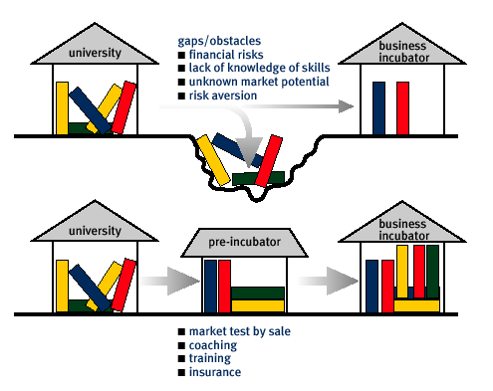
Figure 3 – Pre-incubation model

This model is reinforced by research into the student view of entrepreneurship carried out by Leeds Metropolitan University. It found that the key difference between University students and general entrepreneurs centre on ideas/market, parental support and loans/finance. This backs up academic research that indicates that lack of ideas influences a students entrepreneurial intentions along with socio-economic status
Figure 4 – LMU Study Findings
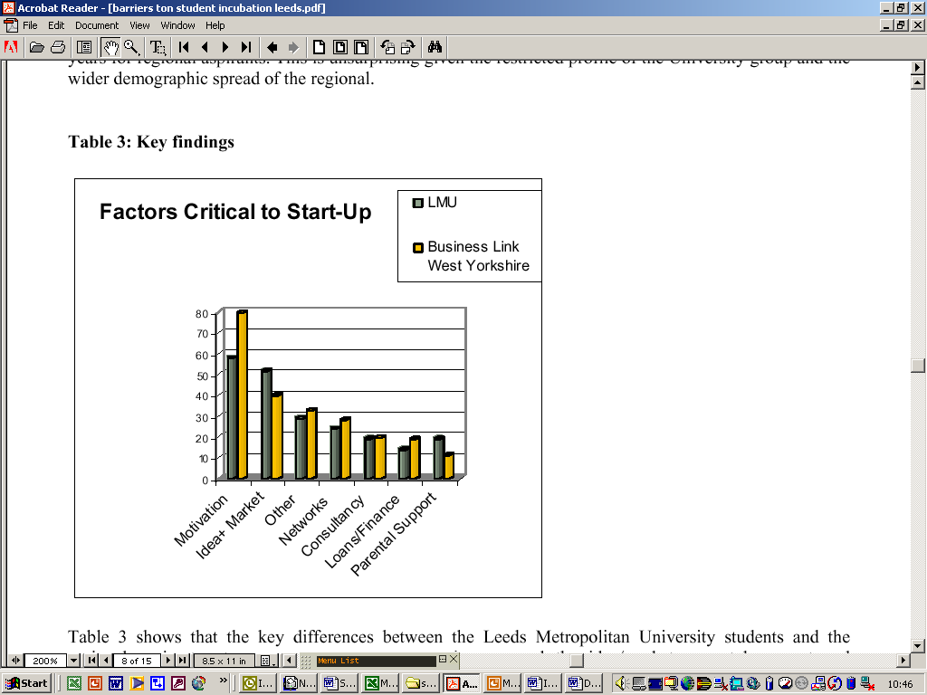

Case Study – University of Abertay/Embreonix

The University of Abertay is actively involved in promoting entrepreneurship by the University's students. The University claims to be the first in Scotland to take steps to provide postgraduate education, training and business advice alongside incubation facilities to support graduates new business enterprises. It provides a number of activities to encourage students to be entrepreneurial outside their individual programmes of study.

It offers a postgraduate Diploma in Enterprise Creation. This offers graduates (or those with equivalent qualifications and/or experience) the opportunity to develop the knowledge and skills required to get a new enterprise off the ground, including the essentials of business planning, management and control. In addition to participating in a study programme specifically designed to lead you through the process of developing an idea into a plan, the students also receive advice from external consultants and mentors as well as having access to the facilities provided by Embreonix, (see 2.7), and the University, offering the student the opportunity to start working straight away on his/her business idea in practice.

Embreonix was established in 2000 to fulfil a gap long identified in national terms. Embreonix provides incubator facilities for students to develop a start up business whilst undertaking the postgraduate diploma in entrepreneurship. This provides them with enhanced business skills for either self employment or business. Minimum entry requirements are that applicants should have a degree and a relevant proposal for business development and be motivated by, and committed to, the challenges of self-enterprise. Candidates will be expected to attend a selection event. In addition, Dare to be Digital, a creative industries competition provides 10 weeks of employment for software and computer arts students to work together in a team to develop a product prototype. Both of these projects have received support from the Local Enterprise Company, primarily contributing to capital and revenue costs associated with the facilities.

The incubator draws upon the support of an external Advisory Panel representing local and national entrepreneurs, professional services companies and business agencies. The Advisory Panel members help select applicants to the Embreonix programme and provide starting points to wider networks of business and professional expertise.

The facilities and services on offer at Embreonix include:

high quality, individual office ‘pods’ with PC, telephone, printer and storage space provided on a free-of-charge basis.

Advice and mentoring from experienced advisors and academic tutors

A weekly allowance (ESF funded) for qualified incubatees

Meeting rooms and common areas for networking with other incubatees

Case Study - Robert Gordon University/University of Aberdeen

The Robert Gordon University (RGU) Incubator was launched in September 1999 as a virtual incubator and is part of the Centre for Entrepreneurship within the Aberdeen Business School. The Incubator aimed to help RGU students and graduates to start successful businesses.

The incubator has is no longer in operation and had been superseded by the Centre for Entrepreneurship. The Centre has a manager whose role is to provide the advice, assistance and mentoring support once provided by the Incubator.

The core objective of PGU/University of Aberdeen Centre for Entrepreneurship is to respond to the vision of entrepreneurship and build on the frameworks to develop an internationally renowned centre of excellence by: conducting and publishing research into entrepreneurship locally, nationally and internationally from a range of disciplinary perspectives; developing entrepreneurial knowledge, attitudes and skills in undergraduate and postgraduate students and in staff across the Faculties of the University and nurturing strong external networks and linkages to support entrepreneurship and business development beyond the confines of the university itself.

Case Study – Cambridge Enterprise

Cambridge Enterprise, part of Cambridge University's Research Services Division, encourages and supports the commercialisation of knowledge from all parts of the University. Services provided to academics include the identification, protection and licensing of IP; support, advice and mentoring in the creation of new companies; provision of seed funds and links to organisations providing further funding; and costing, contract negotiation, invoicing, insurance and VAT support for staff who provide consultancy services to external organisations; and links to industry through showcasing and networking events. It starts up approximately 5 new ventures per annum.

Situated within Cambridge Enterprise the Centre for Entrepreneurial Learning, (CfEL), mission is to 'Spread the Spirit of Enterprise'. It delivers a range of educational activities on the practice of Entrepreneurship, to inspire and build skills. One of is core values is to involve seasoned entrepreneurs in teaching our courses as they have the credibility to teach entrepreneurship through their own experiences to inspire future entrepreneurs. CfEL delivers elective modules on Entrepreneurship within a number of undergraduate and graduate programmes, including the MBA programme.

In addition to these activities CfEL provides a portfolio of open courses to support people from when they have decided whether Entrepreneurship is for them, through to the early stages of start-up. CeFL delivers a range of teaching programmes focused on knowledge intensive entrepreneurship. These courses are delivered to audiences drawn from across the University of Cambridge and the business community. Master Classes: one day workshops on 'hot' topics in enterprise, run by experienced entrepreneurs; Summer Schools: intensive one-week course aimed at students, entrepreneurs and corporate R&D staff wanting to take the first steps in turning ideas into a business. The week focuses on developing a business plan for your technology venture, and a plan for progressing it through the early stages. Surgeries for Entrepreneurs: surgeries to help University of Cambridge Entrepreneurs overcome problems and issues. They also there is an experiential learning programme, called Enterprising Students, gives students the opportunity to take on a key project in a local start-up over the summer.

Case Study – Leeds Metropolitan University

Leeds Metropolitan is one of the most active Higher Educational Institutes when it comes to graduate enterprise. They have developed a set of support activities based upon the Motivation, Ability, Ideas and Resources model as illustrated in table below.

The Leeds Metropolitan University (LMU) product is named Business Start-Up @ Leeds Met (www.business-start-up.biz) and is a government funded project based at Headingley Campus. Its mission is ‘… It provides services to students and graduates such as:

Free workshops for business idea generation and development backed up by a start-up CD-ROM

Advice and mentoring from experienced advisors form the local Business Link network

Pre-start support for researching and developing the business proposition

Summer Schools – week long events with advice from professionals peer entrepreneurs and with networking opportunities

The University is also active in researching and publishing papers on student entrepreneurship. There are also close links with the University of Bradford's Think Business@Bradford programme which also supports those students who are considering launching their own business venture.

As mentioned in 2.18 LMU has used the MAIR model to research its offerings and this has led to the development of a structured enterprise development programme which is illustrated in Figure 3.

Figure 5 – The LMU/West Yorkshire Universities Graduate Enterprise Offering
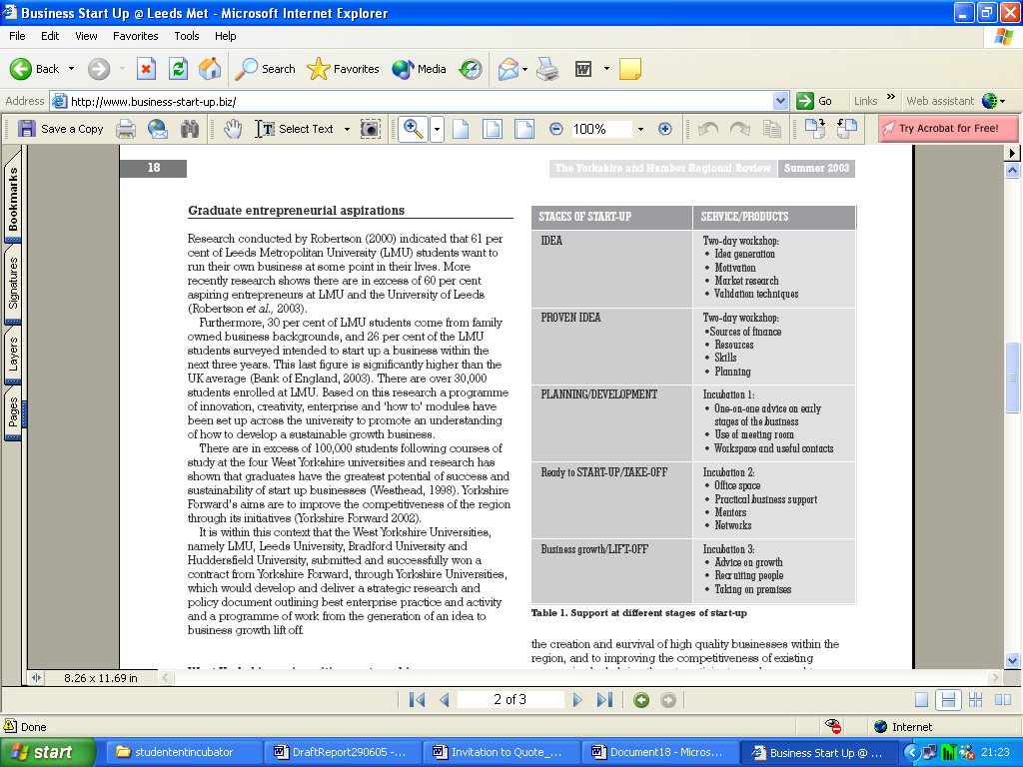

CSES/EC benchmarking of Business Incubators

This is probably the most pertinent and timely study in relation to the SEI. It was undertaken for the European Commission by the Centre for Strategy & Evaluation Services (CSES) in 2002. Its objectives were:

to define ‘headline’ benchmarks for business incubators relating to their performance with regards to management and promotion

provide operational benchmarks that would define the means by which the headline benchmarks could be achieved

assist the participating incubators in implementing the required operational improvements by publishing best practice metrics

The first step was to develop a generic business incubator model setting out basic functions and operating procedures. This model is outlined in Figure 4.

Figure 6 – The EC Incubator Development Model
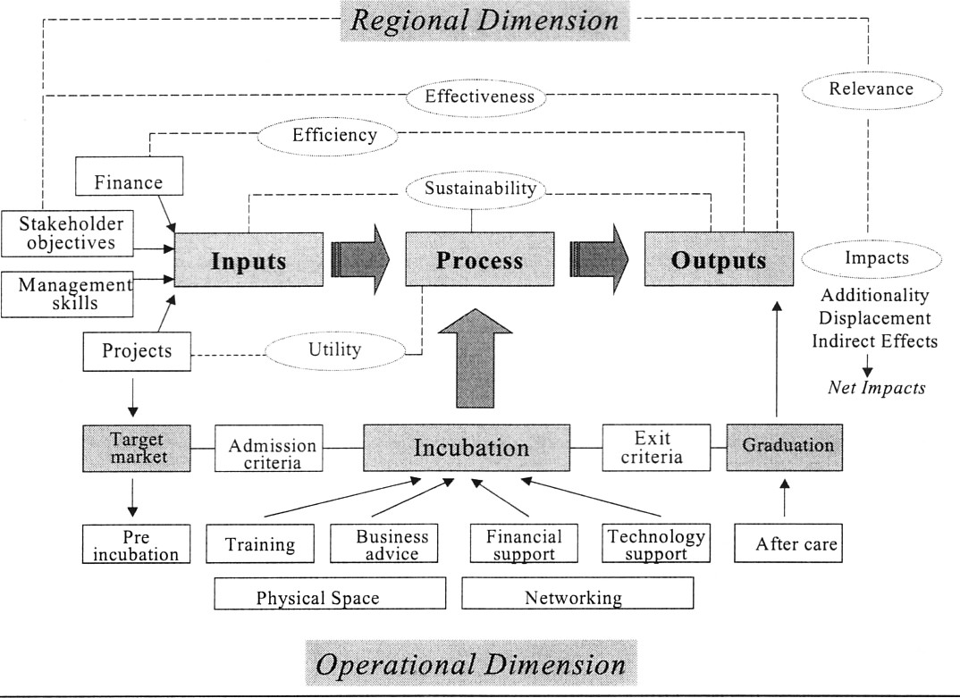

The model above depicts business incubators in terms of a simple input/output model. The inputs are primarily those of the stakeholders, management resources and the projects put forward by entrepreneurs. The processes are incubator space, facilities and services. The outputs are graduate companies and positive job and wealth creation impacts on local economies.

In Figure 4 the input-output model is in the bottom half of the diagram and key best practice issues in the top.

Projects are identified that meet the criteria used to define the incubator’s broad target market (in the case of SEI – student enterprise). The incubation process typically brings together three categories of business support services – training/advice on business issues, financial support and technology support. The provision of incubator units and networking constitute other basic features of the incubator package.

A key feature of incubators is the limited duration of assistance with exit criteria typically specifying that firms should graduate after a fixed period of time. Often contact will be maintained with graduate companies through the provision of after-care services and networking.

The key best practice issues are:

efficiency – the relationship between financial inputs and outcomes and the related issue of value for money

effectiveness – the extent to which the outcomes demonstrate that specific objectives are being achieved

relevance – the extent to which objectives/outcomes promote broader policy objectives

utility – the degree to which services provided to client companies meet their needs

sustainability – the sustainability of operations and durability of outcomes achieved
SFEDI Quality Benchmarks for Business Incubators

The study by the Small Firms Enterprise Development Initiative (SFEDI) aimed to use benchmarking as a way of promoting quality and consistency of service within the UK incubation community. Once established these benchmarks were piloted by ten incubators at various stages of development and across a number of technology domains. A key objective was to encourage the provision of learning and skills development opportunities that will accelerate the growth of incubator clients.

The UKBI National Incubation Benchmarking Framework defines core processes and services that all incubators should strive to provide clients. They are illustrated in Figure 5 below. It also details a range of optional services that some incubators may need to provide; in the case of the SMC one of these would be the provision of specialist equipment and services.

Figure 7 – the incubator environment

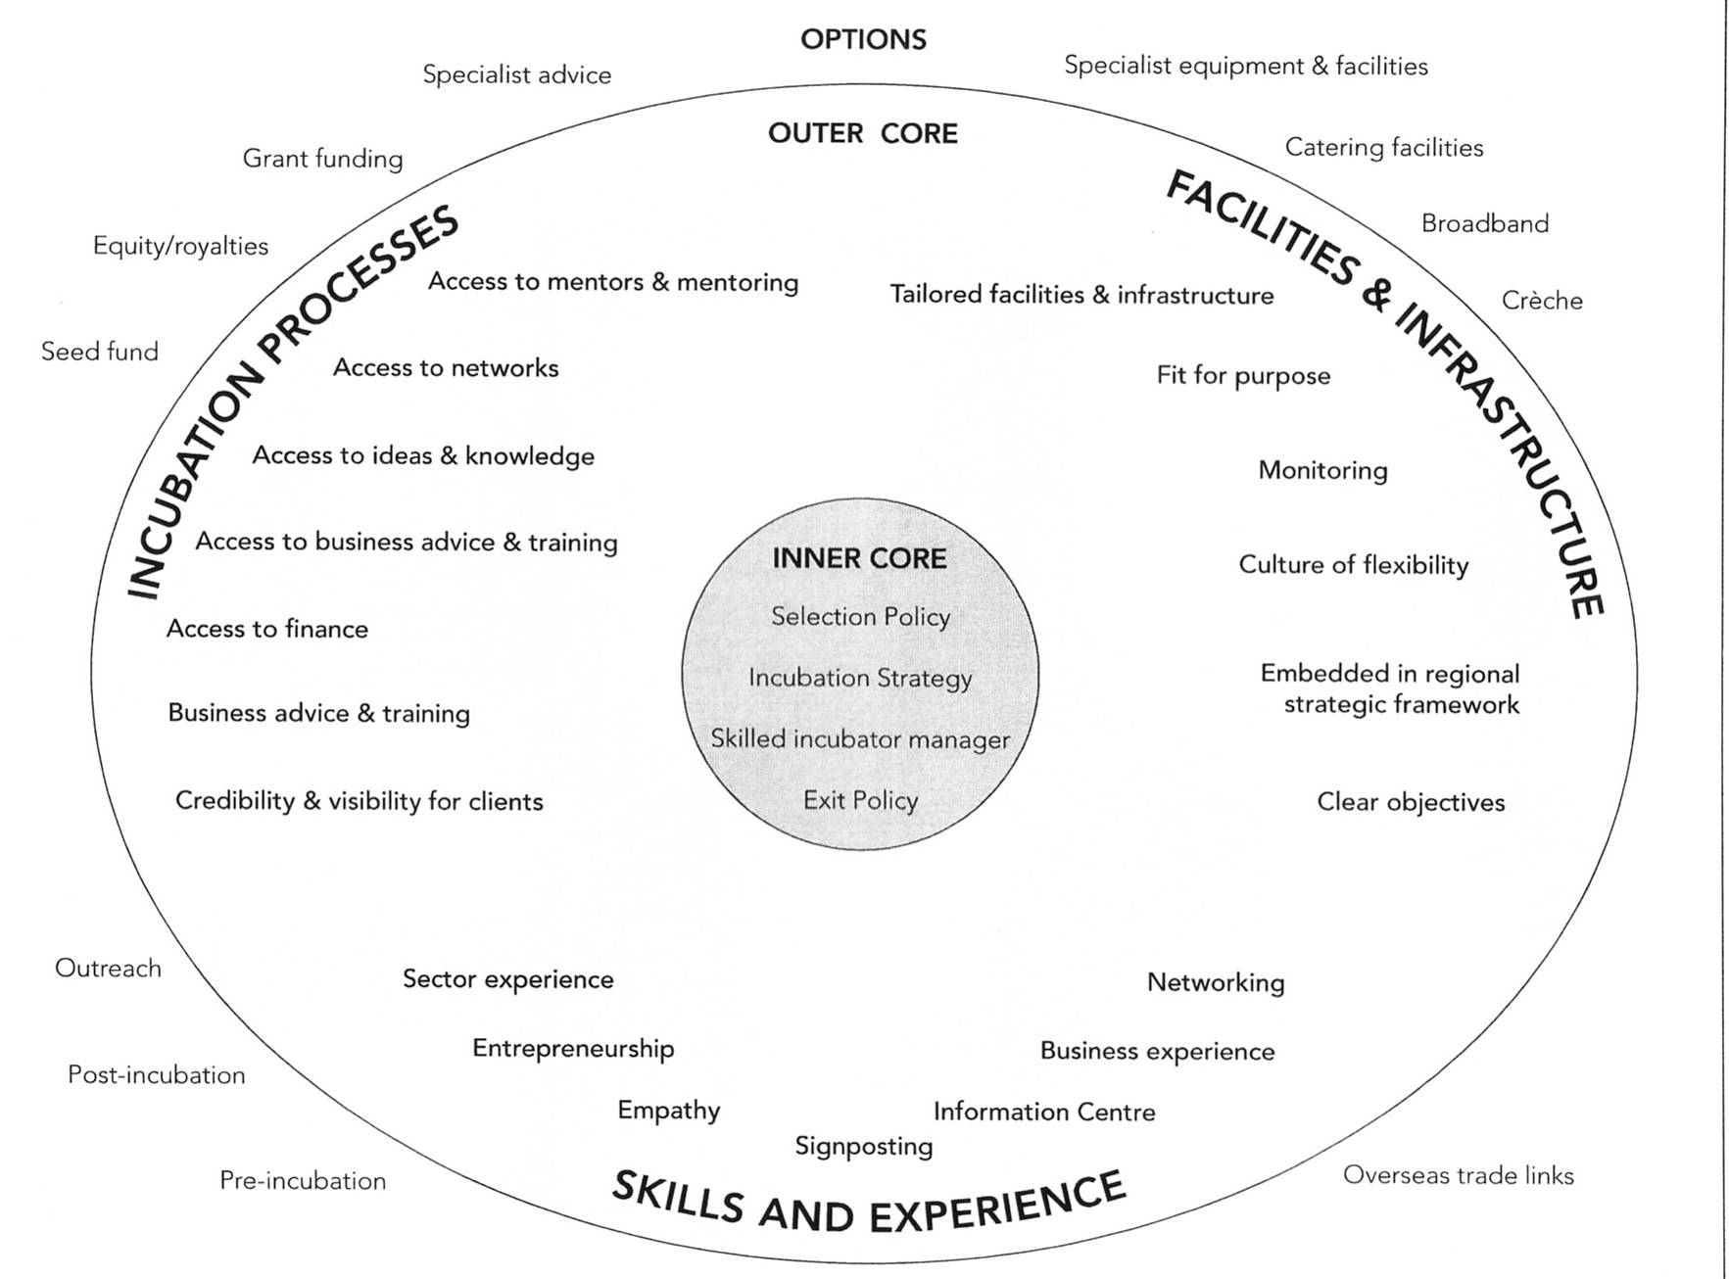

The UKBI benchmarks are divided into four key areas – effective management strategy and policy, skills and experience, client support and effective management processes and systems. Each of these is then divided into a set of twelve principles and indicators that promote good practice. Some example principles are:

demonstration of the effective management of the entry and exit policies

demonstration of the effective management of the incubation strategy

incubator management has the appropriate skills and experience (general/sectoral) and an entrepreneurial approach

incubator management builds trust with client companies, provides mentoring and assists in client’s networking

incubator management effectively monitors the performance of the incubator and its client companies

Key observations relevant to SEI

The case studies confirm that the SEI occupiers a distinctive and valuable part in the overall incubation process. Its services fit closely with the key stages illustrated in Figure 3 Section 2.20.
Incubator set and operational planning

The SEI as an incubator should be seen as part of a broader strategic regional development framework. Its operation should integrate with and complement other initiatives e.g. the Grangemouth Enterprise Incubator.

There needs to be a defined and visible business case for the SEI and this should be developed in a business plan with clear metrics and milestones. The milestones should relate to student contacts, companies formed, products developed and the value to the University and its partners (including the local FE network)

There needs to be clear entry and exit strategies and criteria for tenant firms

The SEI needs to retain entrepreneurial leadership and a strong operational management team capable of sourcing or delivering the full range of services required by client firms.
Business incubation services

The SEI needs to continue to deliver (and develop where necessary) value added services to its clients e.g. networking, mentoring and access to financial support. These are important in assisting firms grow and in generating revenue. These value added services are as important as the provision of physical space
Evaluating success

The future effectiveness of the SEI should be assessed not just by direct measures (jobs created etc) but also by secondary measures such as investment in client firms, IPR generated/protected and awards granted.

The SEI should undertake regular business process benchmarking against its peer global peer group. The outcomes of this should inform the business development planning for future periods.

Oxford Trust Annual Innovation Census Report, February 2003
The Young Entrepreneur Factory
NBIA Best Practices in pre-incubation in Higher Education – 18th International Conference, April 2004
Scott Twomey – Journal of Small Business Management (1994)
Wang, Wong and Lu – Entrepreneurial Intentions and Tertiary Education (2001)

