# **Claim guidance for grants of £100,000 or less**

Before we pay out any grant funding, we need evidence to prove that the work has been completed and paid for by the company. This evidence must comply with our audit criteria.

Please refer to these guidance notes before preparing your claim to ensure it meets our requirements. This will avoid us having to ask you for more information.

This guidance is for grants of up to £100,000 (not including SMART grants). For grant awards over this value, please refer to your offer letter.

## Contents

1. Online Grant System (OGS)

### Bank and payment evidence

* 1. Requirements
  2. Example of compliant payment evidence
  3. Non-compliant payment evidence
  4. Credit card payments
  5. International payments
  6. Third party payment platforms (such as PayPal or Upwork)
  7. Bulk payments

### Invoices

* 1. Requirements
  2. Materials
  3. Capital equipment
  4. Flights and accommodation
  5. Exhibition costs

### 4. Payslips and payroll evidence

* 1. Requirements
  2. Salary costs table

### Project update

### Fair work first

### Finalising a claim for payment

## Online Grant System (OGS)

You’ll need to submit your claims and supporting evidence through our Online Grants System (OGS).

The ‘Checklist for claim’ section in OGS lists the information you need to upload to allow us to verify your project costs.

If your project is not on OGS, please refer to the claim form that came with your offer letter for details of how to submit the claim.

## Bank and payment evidence

It’s important that we see evidence that the project expenditure you’re claiming against all took place within the timescales stated in the offer letter.​

### Requirements

This payment evidence must include:​

* Your company name ​– this must be the same company name shown in your offer letter
* The logo of the bank or payment company for the account the payment was made from​
* The payment dates and amounts​
* Details of who was paid

​

We don’t need to see a formal bank statement as long as your evidence shows the required information.​

Also note that:

* Any transactions that are not relevant to your claim can be redacted, or your bank statement can be filtered to show only the relevant payments.
* Your payment evidence needs to be sent as a picture file attachment in a non-editable format (such as a JPEG, PNG, or PDF).
* We cannot accept screenshots of the payment evidence in Word documents, Excel spreadsheets, or emails.
* We don’t need to see the opening and closing balance of your bank statement.

### 2.2 Example of acceptable payment evidence

This image shows an example of payment evidence which includes all the details needed to meet our criteria. The bank name, company name, supplier name, payment amount, and dates are highlighted.

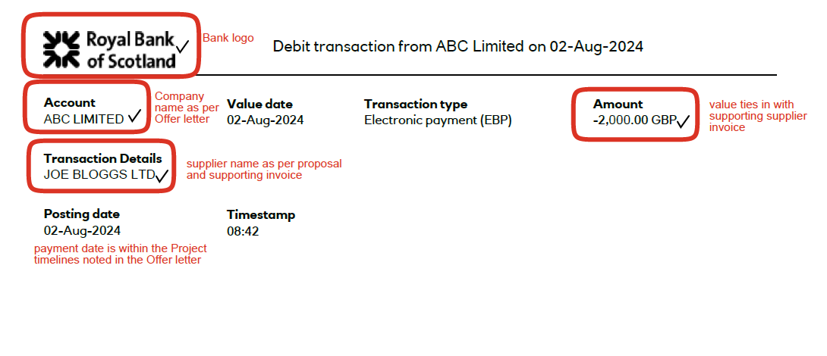

### 2.3 Common reasons that payment evidence is rejected

There may be instances in which the supporting payment evidence does not meet our requirements. Some examples of this are:

* It includes a warning statement such as “If there are insufficient funds in the debit account, the payment will be rejected”.
* It’s shown as future dated, as this suggests that the payment hasn’t been made yet.
* The status of the payment is shown as “received by bank”, which means that the funds have left the account but not yet cleared.
* The transaction does not include the name of the supplier.

If we’re not happy with the documents provided, we’ll ask you for more evidence and explain the reasons for this.

### 2.4 Payment evidence – credit cards

We’ll accept payments that were made using company credit cards. We need to see evidence that at least the minimum payment to the credit card was made from the company’s bank account.

We also accept payments made with personal credit cards, as long as you provide evidence that shows the holder of the credit card was fully repaid by the company.

If you use a credit card, we’ll need:

* A credit card statement that shows the relevant invoice was paid
* A bank statement that shows a payment to the credit card as set out in section 2 of this guidance

Both the credit card statement and bank statement must meet the requirements listed in section 2.1.

### 2.5 Payment evidence – international payments

If an invoice amount is not in pounds sterling, we need to know the currency conversion rate that has been used. If this was not done at the time of payment, the exchange rate should be calculated using the online [EU currency conversion calculator](https://commission.europa.eu/funding-tenders/procedures-guidelines-tenders/information-contractors-and-beneficiaries/exchange-rate-inforeuro_en).

When using the currency conversion calculator, select the month the payment was made to ensure the correct rate is applied.

Bank charges and transaction fees are ineligible and will be removed from the claim calculation.

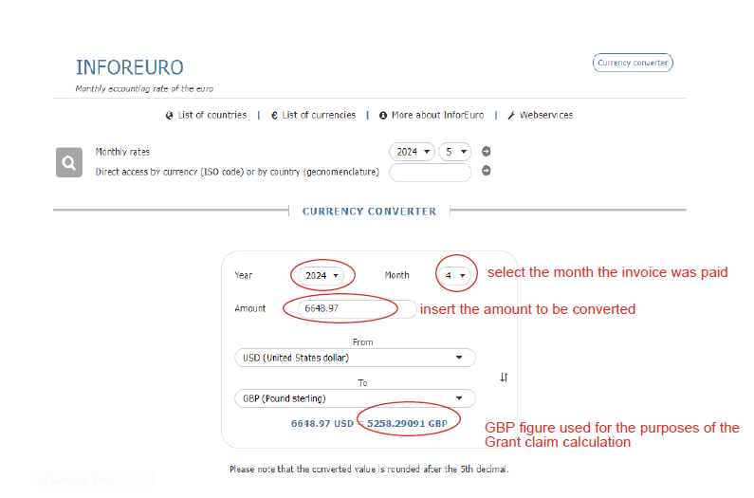

### 2.6 Payment evidence – third-party payment platforms (for example, PayPal or Upwork)

Any payments made using a third-party payment platform must be made from an account in the company’s name.

If you’ve paid an invoice using a third-party payment platform, we’ll need:

* The invoice
* Evidence from the payment platform to show the amount of the payment and who was paid

We may also need one or both of the following:

* A copy of the relevant bank statement
* Confirmation from the supplier that payment has been received (for example, a receipted invoice)

### 2.7 Payment evidence – bulk payments

If a payment was part of a single bulk BACS payment, you’ll also need to provide a BACS transaction list to explain the transactions that make up the payment.

The BACS transaction list must show:

* That it comes from your company’s payment system
* Individual payees, payment amounts, and dates
* That the total payment amount and date on the transaction list matches the amount and date on your bank statement

Here’s an example of bulk payment evidence:

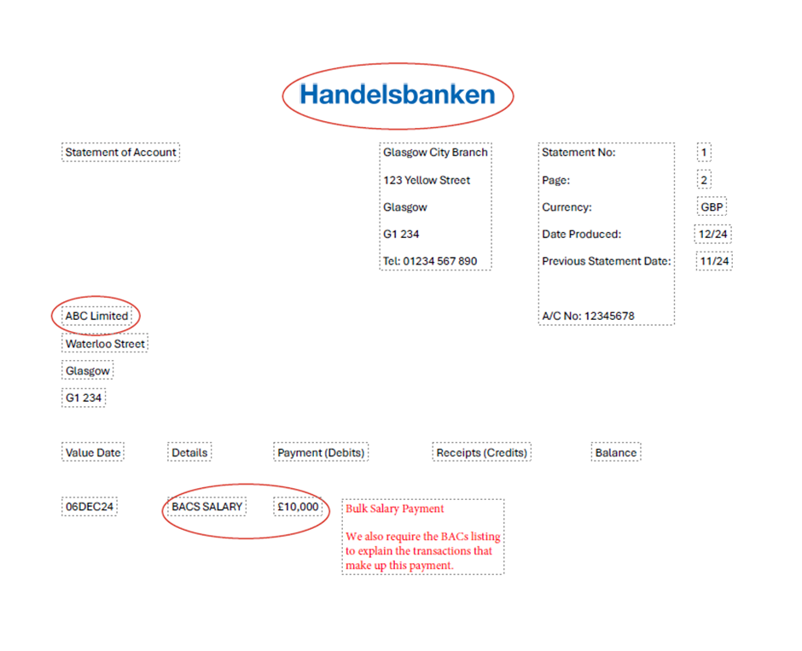

In this example, the company is claiming for salary costs and has provided the relevant payslips and payment evidence.

The bank statement meets our payment evidence requirements as it shows the bank logo, company name (which matches the name in the offer letter), and transaction details. However, as this is a bulk salary payment, we also need a copy of the BACS listing which provides a complete list of the individual salary costs that make up this payment.

Here’s an example of a satisfactory BACS listing:

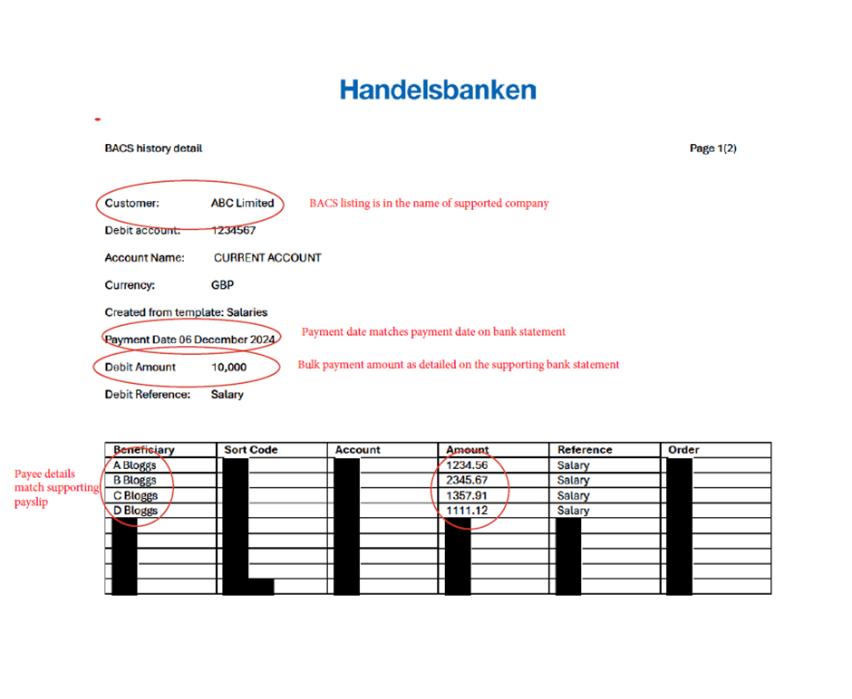

This BACS listing is satisfactory as:

* It shows the company name
* The bulk payment amount matches the total shown on the bank statement
* The BACS listing provides a breakdown of the salary costs which match the supporting payslips

All other information not relevant to the claim has been redacted.

## Invoices

Invoices and supporting payment evidence are needed for the following costs:

* Sub-contractors
* Consultancy
* Materials
* Capital equipment
* Flights and accommodation
* Exhibition costs

### 3.1 Invoice requirements

All invoices you submit to us should:

* Be addressed to your company
* Be dated after the project start date and before the project end date, as shown in your offer letter
* Contain a summary of what you’ve paid for – for example, materials, equipment, or services
* Relate to a proposal or quote you received from the supplier when planning the project
* Show the net cost, VAT, and gross cost (as VAT is an ineligible cost, your grant will be based on net costs)
* Be paid in full before the deadline for submitting your final claim

If you’ve changed supplier since your original application, please speak to your project manager (as detailed in your offer letter) to make sure that this change is acceptable to us.  If it is, you’ll need to provide us with a proposal from the new supplier.

The following costs are not eligible to be included as part of a claim:

* Any travel and subsistence costs, unless specifically included in your offer letter – see section 3.4 for more about these costs
* Pro-forma invoices
* Any invoice for less than £100 (excluding VAT)

As well as these general points, there are some specific requirements for certain types of expenditure, including materials, capital equipment, flights and accommodation, and exhibition costs.

### 3.2 Materials

Only new materials bought after the start of the project are eligible. If stock bought before the project start date has been used, this must have been agreed with your project manager during the application process.

### 3.3 Capital equipment

The capital equipment must be on site before we pay your final claim.

You cannot claim the cost of transporting or delivering the asset to the project location.

If the asset was purchased under a finance lease, hire purchase, or extended credit, we’ll need a copy of the signed finance agreement before we make any payments. We’ll also need bank evidence of the deposit and instalments that have been paid out. These payments must be for more than the amount of the grant we’re paying out (excluding VAT and any interest).

### 3.4 Flights and accommodation

3.4.1 Accommodation costs

You’ll need to provide an invoice or other evidence from either the hotel or a booking agent such as Airbnb, Booking.com, or Expedia that shows the:

* Dates of the stay
* Number of guests
* Costs
* Location of the accommodation

#### 3.4.2 Flight costs

Acceptable evidence for flights can be in the form of an invoice, booking confirmation, or an e-ticket. The document must include the:

* Supplier name – for example, the airline or travel agent
* Passenger names
* Date of booking
* Flight destination
* Date of travel
* Class
* Cost breakdown

It is important to note that you can only claim for basic economy class flights. Higher classes, such as economy premium, private, and business class flights, are not eligible for support. There is no exception to this rule, including for long haul flights. If you upgrade a flight, we’ll no longer be able to pay for the original basic economy ticket. You cannot claim for cancellation fees or costs associated with changing flights.

### 3.5 Exhibition costs

The following exhibition costs areeligible:

|  |  |
| --- | --- |
| Design of stands | Design of your exhibition stand and related marketing or promotional materials (such as graphics) |
| Erection of stands | * Cost of the physical stand, including a custom-built stand or a shell scheme or equivalent * Labour costs for the physical construction of the stand * Costs of heating and power supply * Rental of stand carpets and furniture * Stand cleaning * Internet or phone connection and rental, excluding call charges * Production of display aids and graphics, excluding any products or samples unless they’re part of the stand construction |
| Exhibition space costs | The actual amount paid for space at the venue and any other mandatory charges such as attendance fees, registration fees, or catalogue entry charges. These charges will normally be no higher than the rates published by the organiser of the exhibition. |

The following costs cannot be included in your claim, although this isn’t a full list. If in doubt, please check with your contact at Scottish Enterprise.

* The purchase of items for your stands
* Shipping goods to an event
* The purchase and/or printing of promotional goods – although design costs are eligible under the consultancy cost heading
* Car hire
* Mileage
* Petrol
* Subsistence, including food, drinks, tips, and laundry services
* Parking costs
* Train – with the exception of in-market train fares
* Taxis
* Mobile phone call charges
* Visas
* All transaction charges, including credit card fees, purchasing currency, currency conversion fees, and fees for withdrawing cash abroad

## Payslips and payroll evidence

We’ll need payslips as evidence if you are claiming any of the following costs:

* Internal staff costs
* Temporary specialists (on payroll)
* Graduates (on payroll)
* Workplace transformation training

### 4.1 Salary cost requirements

You must provide payslips for each employee who worked on the project or payroll information for each month of the project, with supporting payment evidence.

The payroll information must show the:

* Dates of payment
* Names of employees
* Gross pay
* Company name

Please note that:

* Only basic gross pay is eligible.
* Employers’ National Insurance and pension contributions are ineligible.
* Staff must work a minimum of 0.5 days on the project for their salary costs to be eligible.
* Pay increases, bonus payments, car allowance and other incentive payments are ineligible. As with all eligible project costs, we can only pay against what is actually spent – this may be lower than the original estimated salaries.

### 4.2 Salary costs table

Please complete and upload the **[salary costs table (Word, 29 KB)](https://scotent-live-sec-cms.azurewebsites.net/media/1mcgnczu/salary-summary-sheet-small-grant-claims.docx)** to the ‘Checklist for claim’ tab on OGS. This should show each employee’s full-time salary (or full-time equivalent salary if they work part-time) and how much of their time is being spent on the project.

Providing this information at the start of the project ensures that we have all of the information we need to calculate the eligible salary costs correctly.

## Project updates and reports

We may need a written update on the project before we pay your claim. This could be a project update, a project closure report, or a consultant’s report. Please refer to your offer letter to see what’s needed.

However, in most cases, the following updates will be needed:

* For interim claims, we need an update on how the project is progressing. This can be included in the ‘Additional Grant Claim Notes’ section of the ‘Grant Claim’ tab on OGS or uploaded as a Word document in the ‘Checklist for Claim – Project Update’ section.
* For final claims, we need a full report on all activities carried out during the project, as well as the outcomes of the project.
* The report should be uploaded as a Word document in the ‘Checklist for Claim – Project Update’ section of OGS.
* If your project is not managed through OGS, please provide an update in section 2 of the claim form.

## Fair Work First

We are committed to championing fair work practices. As part of your grant application, you’ll have been asked about your fair work practices. The Scottish Government asks us to check a random sample of the projects we give grant funding to in order to make sure that fair work principles have been adopted as the project is delivered.

If your project is selected, the following evidence must be uploaded to OGS:

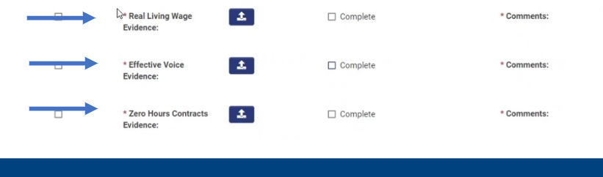

|  |  |  |
| --- | --- | --- |
| **Fair Work First criterion** | **What you need to demonstrate** | **Evidence required** |
| Real Living Wage | We need to see evidence that you pay the real Living Wage to all staff aged 16 and over directly employed by the company in the UK. | Payroll or payslips for all employees in Scotland. If you have more than 250 employees in Scotland, please provide a 20% sample of your payroll or payslips. |
| If you have subcontractors, you need to show us evidence that all employees aged 16 or over working directly on the project are paid at least the real Living Wage. | A copy of the contracts for any subcontractors that show that a real Living Wage contractual clause is included. |
|  |  |  |
| Zero-hour contracts | We need to see evidence that you are not making inappropriate use of zero-hour contracts. | A copy of your company policy showing there is a clear, published policy and process to enable someone to request a move from a zero-hour contract to guaranteed and set hours – for example, evidence that terms and conditions are the same as for FTE staff.  Appropriate use of zero-hour contracts can include hours being mutually agreed and documented, a minimum number of hours agreed, and an agreed notice period for cancellation of shifts. |
|  |  |  |
| Individual and collective voice | We need to see evidence that you provide appropriate channels for individual and collective voice.  If you have fewer than 21 workers, you’ll need to supply evidence of individual voice only. | Examples ofindividual voice channels and evidence are:   * Regular staff surveys and improvement plans * One-to-ones between workers and management – evidence could be diary invites or minutes * Policy documents explaining how management should check in with their direct reports * Evidence of team meetings, such as agendas or minutes from meetings or screenshots of diaries showing these meetings in place * Performance appraisal or feedback processes – for example, a performance policy document or appraisal process document   Examples of collective voice channels and evidence are**:**   * Recognising trade unions and making workers aware that they can join a union of their choice – evidence could be, for example, minutes from a union meeting or an agreement you have with your union * Involving trade union/worker representatives in key governance and decision-making structures – demonstrated through minutes from meetings where key decisions were made which show union participation * Intranet or social media platforms – evidence could include screenshots which show two-way communication with staff * Company ‘town hall’ meetings – evidence could be an email invite to such a meeting which was sent to colleagues, as well as minutes from these sessions * Employee forums and focus groups – backed by minutes from these meetings or remits/terms of reference for such groups |
|  |  |  |

## Finalising your claim for payment

Once you have submitted your claim and supporting paperwork through OGS, it will be assigned to one of our grant specialists.

They’ll review the documentation to ensure it meets our evidence requirements.

If we need more information or clarification, we’ll contact you with details of what is needed to move your claim process forward.

Please note that if the evidence you provide is incorrect or incomplete, it will affect the length of time it takes us to process your claim. If you have any questions while completing your claim, please don’t hesitate to contact us. We aim to pay claims within 30 days of receiving all the necessary and correct information.